**Routing Practice**

Create a simple React app that can handle the following routes:

1. localhost:3000/home: This should display the home page, with a generic "Welcome" heading

2. localhost:3000/4: This should display the number "4", or any other number that was sent through

3. localhost:3000/hello: This should display the word "hello" or any other word that was sent through

4. localhost:3000/hello/blue/red: This should display the word "hello" in blue text with a red background. It should work with any other valid word and colors.

Hint: use the isNaN method (is Not a Number). For example: isNaN(+"35") is false, isNaN(+"hello") is true

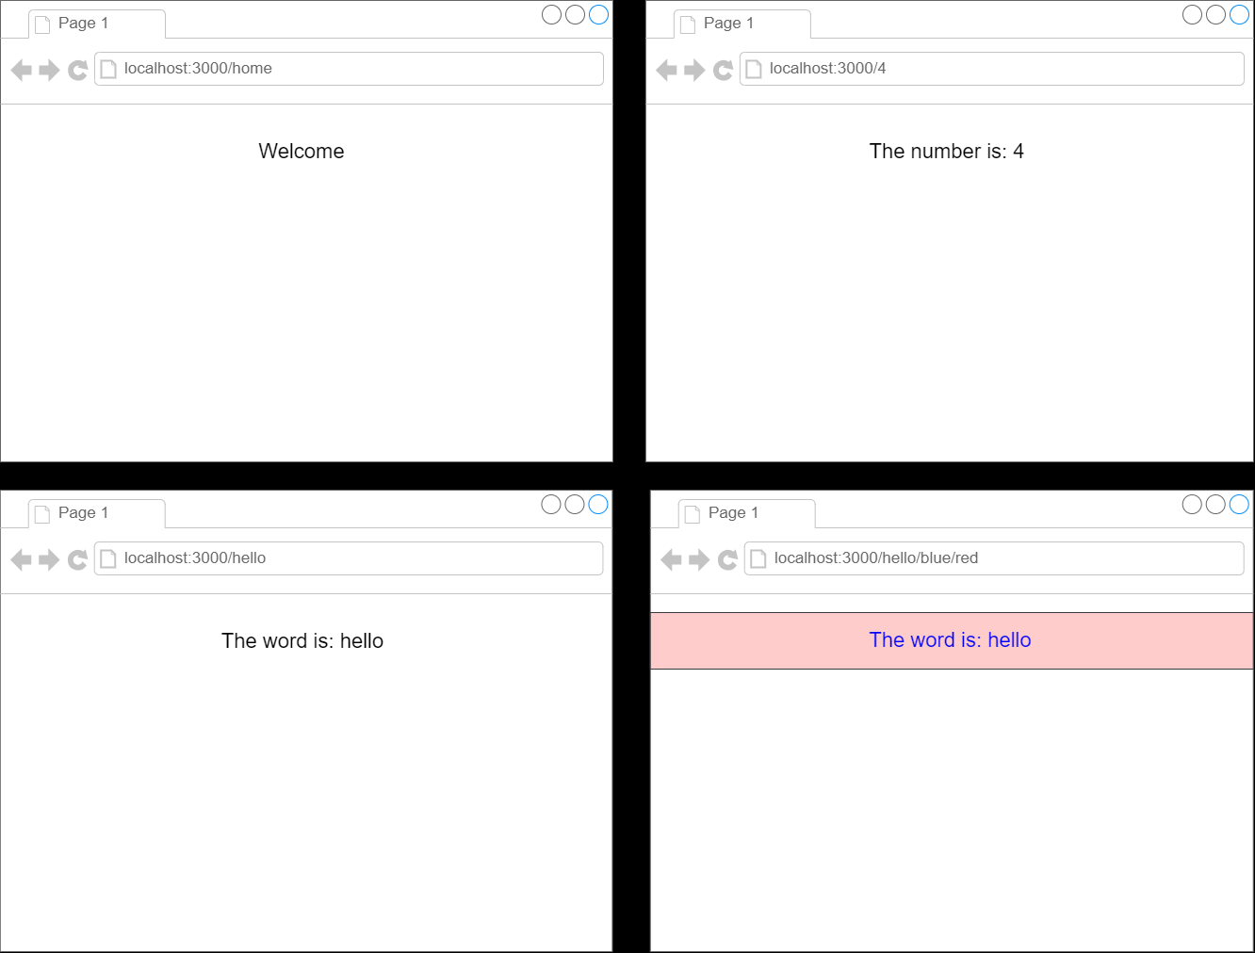

* Top of Form
  + Create localhost:3000/home: This should display the home page, with a generic "Welcome" heading
  + Create localhost:3000/4: This should display the number "4", or any other number that was sent through
  + Create localhost:3000/hello: This should display the word "hello" or any other word that was sent through
  + Create localhost:3000/hello/blue/red: This should display the word "hello" in blue text with a red background. It should work with any other valid word and colors.

Bottom of Form